Om Thanage - 16010123217

Fibonacci Series:
#include <bits/stdc++.h>
using namespace std;
#define int long long
#define endl "\n"

const int MOD = 1e9 + 7;
const int INF = LLONG_MAX >> 1;

void fibo(int n){
int a = 0, b = 1;
cout<<a<<" "<<b<<" ";
for(int i = 2; i < n; i++){
int c = a + b;
cout<<c<<" ";
a = b;
b = c;
}
cout<<endl;
}

signed main(){
ios::sync_with_stdio(false); cin.tie(NULL);

int n; cin>>n;
if(n < 0){
n -=(2*n);
}
fibo(n);

cout<<endl;
return 0;
}

Output:
Testcase 1:
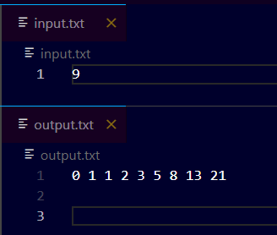

Testcase 2:
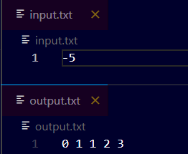
Palindrome
#include <bits/stdc++.h>
using namespace std;
#define int long long
#define endl "\n"

const int MOD = 1e9 + 7;
const int INF = LLONG_MAX >> 1;

bool palindrome(string s){
int n = s.size();
int l = 0, r = n-1;
while(l < r){
if(s[l] != s[r]){
return false;
}
else{
l++;
r--;
}
}
return true;
}

signed main(){
ios::sync_with_stdio(false); cin.tie(NULL);

int n; cin>>n;
vector<string> s;
for(int i = 0; i < n; i++){
string temp;
cin>>temp;
s.push_back(temp);
}
for(auto i: s){
if(palindrome(i)){
cout<<"Yes"<<endl;
}
else{
cout<<"No"<<endl;
}
}

return 0;
}

Output:
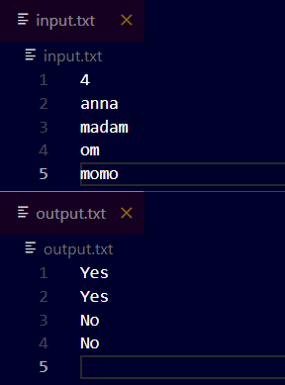

Array Rotation:
#include <bits/stdc++.h>
using namespace std;
#define int long long
#define endl "\n"

const int MOD = 1e9 + 7;
const int INF = LLONG_MAX >> 1;

void arrRotation(vector<int> &a, int pos, char dir){
int n = a.size();
switch(dir){
case 'a':
for(int i = 0; i < pos; i++){
int temp = a[0];
for(int j = 0; j < n-1; j++){
a[j] = a[j+1];
}
a[n-1] = temp;
}
break;
case 'c':
for(int i = 0; i < pos; i++){
int temp = a[n-1];
for(int j = n-1; j > 0; j--){
a[j] = a[j-1];
}
a[0] = temp;
}
break;
default:
cout<<"Invalid direction"<<endl;
return;
}

for(auto i: a){
cout<<i<<" ";
}

}

signed main(){
ios::sync_with_stdio(false); cin.tie(NULL);

int n; cin>>n;
vector<int> a(n);
for(int i = 0; i < n; i++) cin>>a[i];
int pos; cin>>pos;
char dir; cin>>dir;
arrRotation(a, pos, dir);

return 0;
}

Output: Anticlockwise
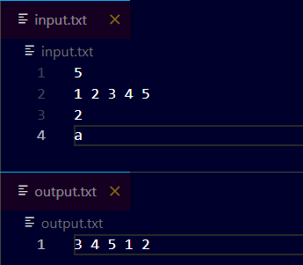
Clockwise:
